**Watch Method**

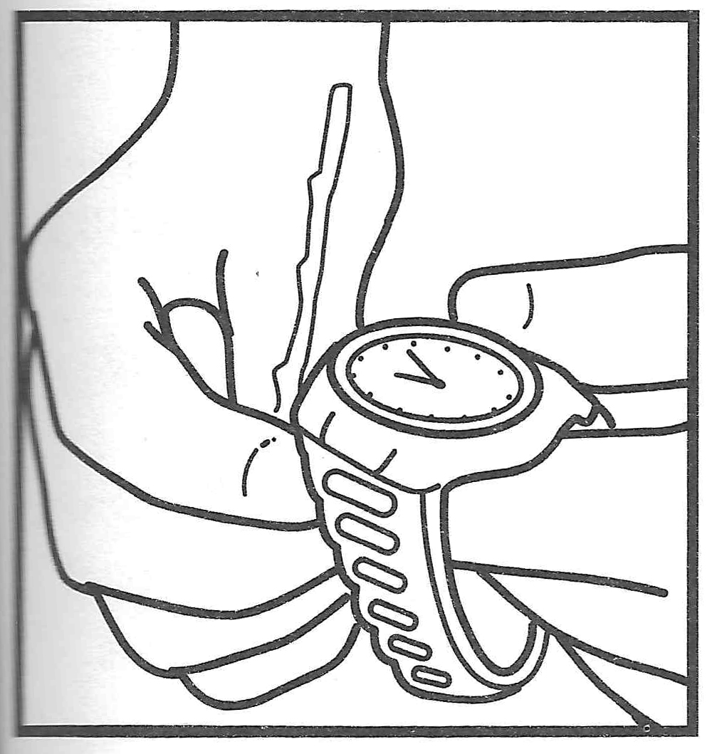

**Equipment:**

* Watch (preferrably with hands), and thin twig/pencil
* One 6-8 inch straight stick or dowel
* 5-6 feet of string/twain/parachute cord
* 2- or 3-foot straight stick/dowel, and two (4-inch) pegs

**Watch Method**

1. Hold your watch level.
2. Place a short, straight twig upright against the edge of the watch at the point of the hour hand.

(Note: If using a digital watch, not the hour, imagine where the hour hand would be point, and place the twig accordingly.)

1. Turn the watch until the shadow of the twig falls along the hour hand's position—that is, until the hour hand points toward the sun.
2. Notice the angle formed between the numeral 12 (the top half of the digital watch) and the shadow lying on the real or imaginary hour hand.
3. A line from the center of the watch that divides that angle in half will point South.

*Note: This method requires standard time. If your watch is set on daylight savings time, turn it back one hour.

**Shadow-Stick Method**

1. Push a short (6-8 inch), straight stick into the ground.
2. Angle it toward the sun so that the stick makes no shadow.
3. Then wait until it casts a shadow at least 6 inches long.
4. The shadow will be pointing east from the stick.
5. A line at right angles across the shadow will be north—south.

**Shadow-Stick Method**

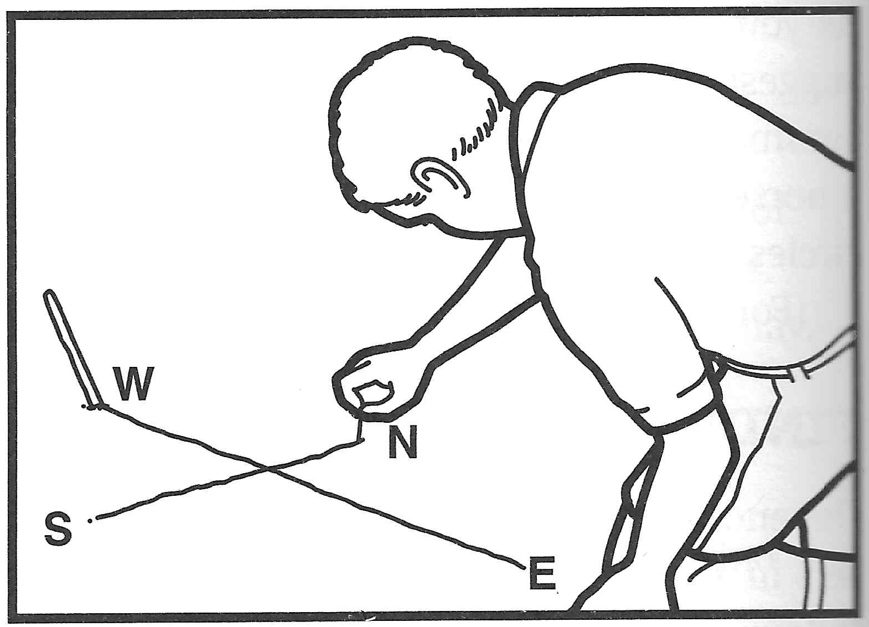

**Object:** Teach how to use the sun and common objects to find directions—north, south, east, and west.

**Equal-Length Shadow Method**

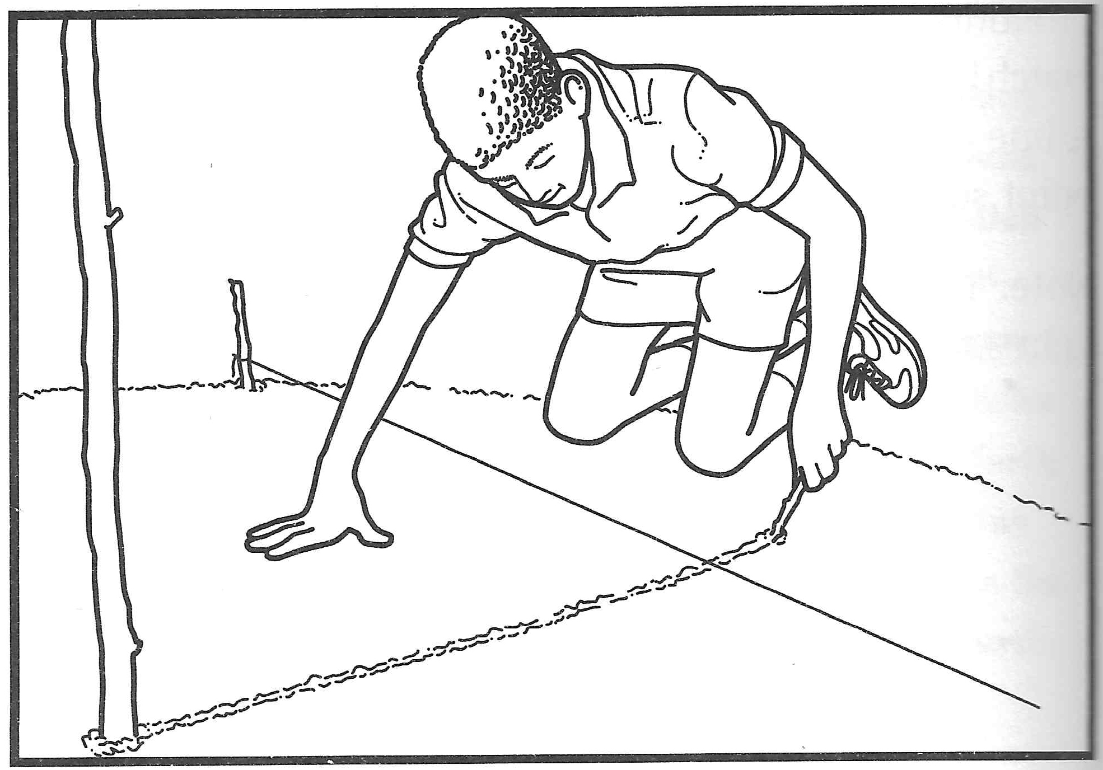

**Extra Credit:**

Find directions at night using the *Shadow-Stick Method* and the moon

Explanation—

* The moon rises in the east and sets in the west, as does the sun.
* The shadow-stick method for use with the sun will work just a well on the nights when the moon is bright enough to cause shadows to form.

**Equal-Length Shadow Method**

In the Morning—

1. Push a straight 3-foot-long stick upright into the ground.
2. Tie a string around the base of the stick with a bowline.
3. Next, extend the string to the end of the stick's shadow.
4. Tie a peg to the string at that point and use it to scratch a circle on the ground around the stick.
5. Push the peg into the ground where the tip of the stick's shadow touches the circle.

In the Afternoon—

1. Place another peg where the tip of the shadow again touches the circle.
2. A straight line drawn between the pegs is a west-east line, with West pointing to toward the morning peg.
3. A line drawn at right angles across the west-east line will be north--south.